Mid exam
Note: don’t answer exactly same as my answers in some Questions, but express them with your own language.

Q1. Suppose that you have an array of length N consisting of replications of the string BBBA.
For example, below is the array for N = 16: (four replications of BBBA).
BBBABBBABBBABBBA
I. How many comparisons does selection sort make to sort the array as a function of N?
A: O(n²)
II. How many comparisons does insertion sort make to sort the array as a function of N?
A: O(n²)
III. How many comparisons does merge sort make to sort the array as a function of N?
A: O(n log n)

Q2. For each following code fragment, determine the order of growth of the running time.
You may use an answer more than once or not at all.
Suggested answers:
N, log N, R+N, RN, N+R², (N+R) log N, N (N+R)
int x = 1, i ;
For ( i = 0 ; I < N ; i++ )
x++ ;
A: O(n), because line 2 takes O(n).

A: O(log n), because in line 4 we skip the half every time.
Public static int f2 ( int N ) {
int x = 1 ;
While ( x < N )
x = x * 2 ;
Return x ;
}

A: O(n log n), because f2() takes O(log n) and we repeat it N times.
int x = 0, i ;
For ( i = 0 ; i < N ; i++ )
x+= f2(N)

A: O(RN), because line 3 takes O(R) and we repeat it N times.
int x = 1, i, j ;
for ( i = 0 ; i < N ; i++ )
for ( j = 1 ; j < R ; j++ )
x = x * j ;

A: O(N(N+R)), because line 3 takes O(N+R) and we repeat it N times.
int x = 0, i, j ;
for ( i = 1 ; i <= N ; i++ )
for ( j = 1 ; j <= N + R ; j += i)
x += j;

Q3. Design an algorithm.
I. Describe an algorithm to type text in revers order; what the asymptotic running time of this algorithm is, give an example.
int left = 0, right = str.length() - 1;
while (left < right) {
swap(str[left], str[right])
left++; right--; }
A: Running time: O(n/2), simplified to O(n).
This algorithm swaps the two ends until we reach the middle.

II. Describe a linear-time algorithm for reversing a queue Q. To access the queue, you are only allowed to use methods of queue ADT. Hint: Consider using an auxiliary data structure.
Stack S;
while (!Q.empty()) {
S.push(Q.front());
Q.pop(); }
While (!S.empty()) {
Q.push(S.top());
S.pop(); }
A:

III. Design an algorithm to determine if the graph is separable (disconnected) or not?
A: Use graph traversal algorithms like Depth-First Search (DFS) or Breadth-First Search (BFS), if there is a node unvisited then it’s disconnected, otherwise (all the nodes have been visited) it’s connected.

Q4. Execute Prim’s minimal spanning tree algorithm on the graph given below using the vertex START as the source.
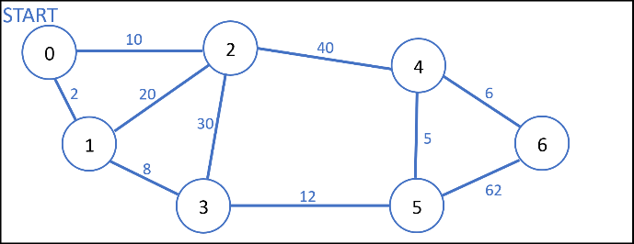
I. Provide an explanation of this execution for the first three iterations.
A: 1. From START we pick the minimal cost of the edges, so we visit node (1) from an edge costed 2.
2. Now from 0 & 1 pick the minimal cost of the edges, so we visit node (3) from an edge costed 8.
3. And from 0,1 & 3 pick the minimal cost of the edges, so we visit node (2) from a edge costed 10.

II. Show the final minimal spanning tree.
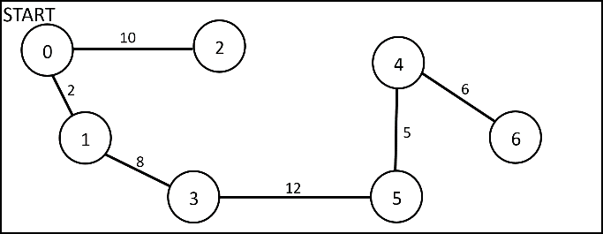
A:

III. Finally. Argue that the minimal spanning tree found is unique for this graph.
A: This is the only MST that can be generated because there are no edges with equal costs.
Q5. What do the following two algorithms do? Analyze its worst-case running time, and express it using \Big-Oh notation.
A: It gives the result of: a^{n}
Worst-case running time: O(n)
It’s really O(n/2) simplified to O(n)
Worst-case would be: n is a prime number, because prime numbers will reach dividing k by 2 less than normal numbers specially if they are powers of 2, if n is a power of 2 it will be the best case by the way, because it will always be divisible by 2 every time you divide it.

Note: gray text is not required to answer, it’s just an extra.
Algorithm Bar (a, n):
Input: two integers, a and n
Output: ?
k ← n
b ← 1
c ← a
while k > 0 do
if k mod 2 = 0 then
k ← k/2
c ← c * c
else
k ← k – 1
b ← b * c
return b

A: It gives the result of: a^{n}
Worst-case running time: O(n)
Because line 6 takes O(n).

Algorithm Foo (a, n):
Input: two integers, a and n
Output: ?
k ← 0
b ← 1
while k < n do
k ← k + 1
b ← b * a
return b

Q6 (bonus). NASA wants to link n stations spread over the country using communication channels. Each pair of stations has a different bandwidth available. NASA wants to select n-1 channels (the minimum possible) in such a way that all the stations are linked by the channels and the total bandwidth (defined as the sum of the individual bandwidths of the channels) is maximum. Give an efficient algorithm for this problem. Consider the weighted graph G = (V,E), where V is the set of stations and E is the set of channels between the stations. Define the weight w(e) of an edge e ∈ E as the bandwidth of the corresponding channel.
A: Instead of using MST by choosing the minimal costs from the edges we choose the maximum cost edges. We can use Kruskal’s algorithm but we sort the edges in reversed order (decreasing).

Q7. Graph representation.
I. Give an adjacency-list representation and an equivalent adjacency-matrix representation for the following graph.
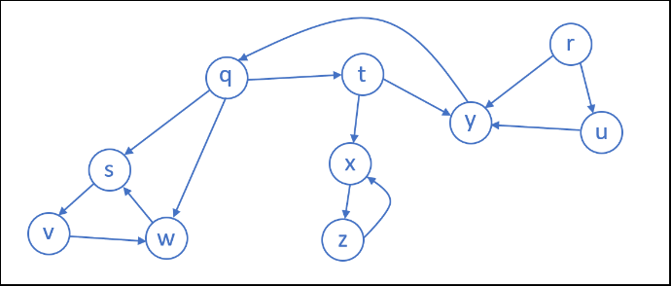
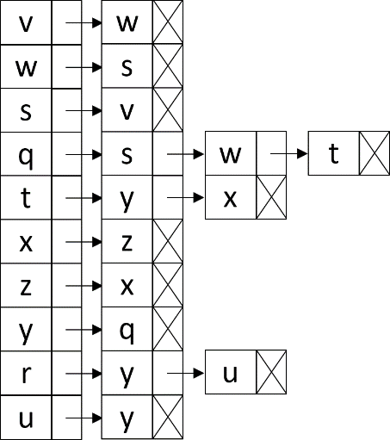
 | v | s | w | q | t | x | z | y | r | u
v | 0 | 0 | 1 | 0 | 0 | 0 | 0 | 0 | 0 | 0
s | 1 | 0 | 0 | 0 | 0 | 0 | 0 | 0 | 0 | 0
w | 0 | 1 | 0 | 0 | 0 | 0 | 0 | 0 | 0 | 0
q | 0 | 1 | 1 | 0 | 1 | 0 | 0 | 0 | 0 | 0
t | 0 | 0 | 0 | 0 | 0 | 1 | 0 | 1 | 0 | 0
x | 0 | 0 | 0 | 0 | 0 | 0 | 1 | 0 | 0 | 0
z | 0 | 0 | 0 | 0 | 0 | 1 | 0 | 0 | 0 | 0
y | 0 | 0 | 0 | 1 | 0 | 0 | 0 | 0 | 0 | 0
r | 0 | 0 | 0 | 0 | 0 | 0 | 0 | 1 | 0 | 1
u | 0 | 0 | 0 | 0 | 0 | 0 | 0 | 1 | 0 | 0
A:

II. Draw the graph represented by the following linked list?
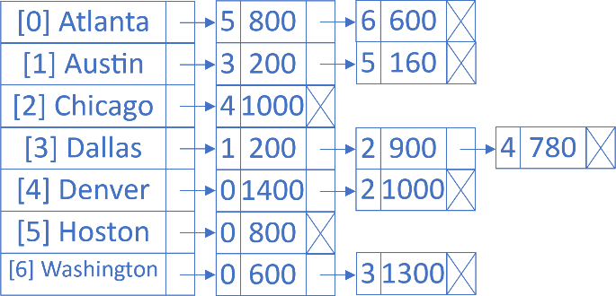

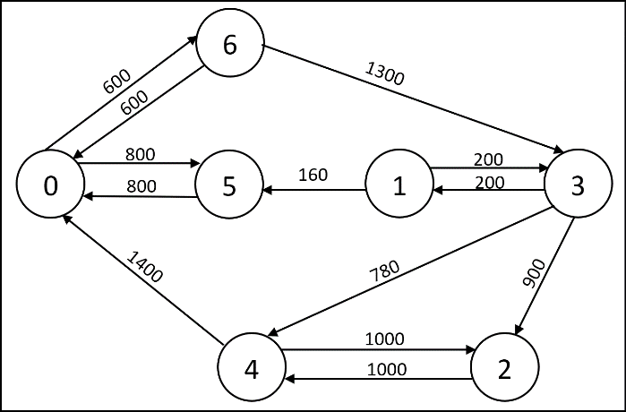
A:

Final exam
Note: don’t answer exactly same as my answers in some Questions, but express them with your own language.

Q1. Construct a binary tree from given Pre & Post order:
I. Pre: F B A D C E G I H
Post: A C E D B H I G F
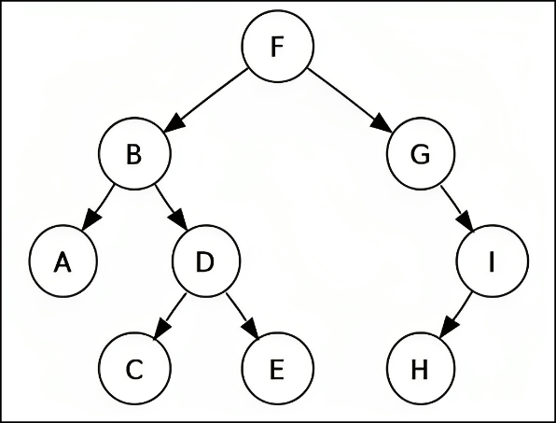
A: Search on YouTube how to construct a binary tree from Pre & Post order.
Extra: Search how to construct tree from
Pre & In order, and post & In order (it’s easier).

Q2. True/False Questions, explain why.
I. Instead of using counting sort to sort digits in the radix sort algorithm, we can use any valid sorting algorithm & radix sort will still sort correctly.
A: False, because the sorting algorithm should be stable like the counting sort.

II. Given an array of n integers. each belonging to (-1, 0, 1), we can sort the array in O(n) time in the worst case.
A: True, using counting sort, all the -1’s placed at first then the 0’s then the 1’s. that will be in O(n).

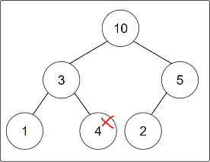
III. The following array is a max heap: [10; 3; 5; 1; 4; 2].
A: False, because the node (4) will be bigger than its parent.

IV. For all positive f(n). g(n) & h(n). if f(n) = O(g(n) & f(n) = Ω(h(n)). then g(n) + h(n) = Ω(f(n)).
A: True, I don’t know why ( I am sorry I didn’t study this )

V. using the definition of Θ, is this correct: n³ = Θ(n⁴) ?
A: I didn’t study this either.

Q3. Consider the following binary search tree. Use the original tree below when answering each subpart (a) through (e).
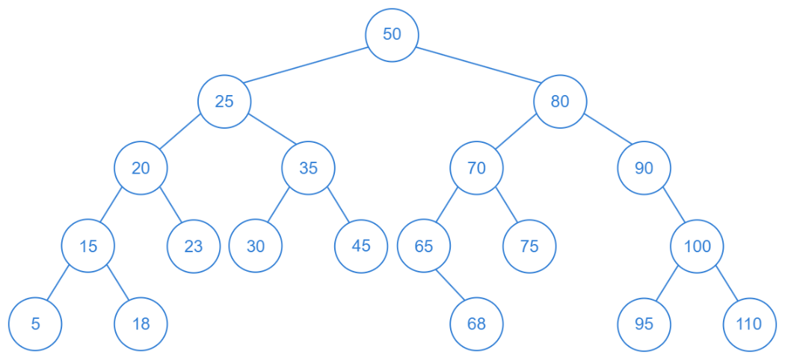
a. If the value 46 is inserted into this tree, which node becomes its parent? A: 45
b. If the value 64 is inserted into this tree, which node becomes its parent? A: 65
c. If we delete node 65, which node should be its replacement node? A: 64
d. If we delete node 90, which node should be its replacement node? A: 100
e. If we delete the root node 50, which node should be selected as its replacement node so that the fewest number of changes are made to the tree? A: 46

Q4. In scheduling final exams for summer semester, six different seats have to be given to seven students. The table below shows the exams that each of the students must take.
Exams | Ali | Ibrahim | Mosa | Majed | Alaa | Saleh | Rawan
Math | X |  | X |  | X |  | X
Art |  | X |  | X |  | X
Science | X | X |  |  |  |  | X
History |  |  | X |  |  | X
French |  |  |  |  | X | X
Reading | X | X |  | X | X |  | X
I. Draw a graph that illustrates which exams
II. What is the minimum number of time slots that will be needed to schedule the six exams & what should be given in each of these time slots?
A: By following the coloring algorithm, we colored the graph (you can mark nodes by shapes instead of colors), we needed 3 colors, now every color is in one slot:
Slot1(Red) | Slot2(Green) | Slot3(Blue)
Math | History | French
Art | Reading | Science

have students in common with other exams
A:
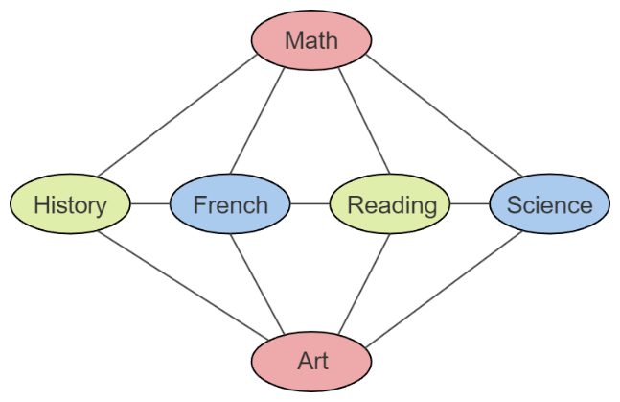

Q5. (Huffman) There is a message contains the letters A, B, C, D, E, with these frequencies:
A: 75, B: 120, C: 90, D: 50, E: 60, F: 30.
I. construct a Huffman tree.
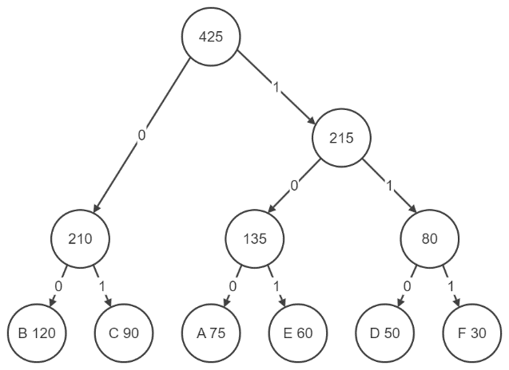
A:

II. Calculate the Huffman codes. ( Show the Huffman table )
Characters | Code
A | 100
B | 00
C | 01
D | 110
E | 101
F | 111
A:

III. Encode this message: FADEBCA.
A: 1111001101010001100
IV. Calculate how many bits we have saved by compressing using the Huffman code.
A: First, we calculate how many bits is the original message:
There is 425 characters, everyone is 8 bits (assuming it’s stored in ASCII code), 425 * 8 = 3400 bits (original)
Then, we calculate how many bits is the compressed message + the size of the table (that we showed before):
There are 75 A’s, & A take 3 bits, so 75 * 3 = 225 bits (for A’s).
There are 120 B’s, & B take 2 bits, so 120 * 2 = 240 bits (for B’s).
There are 90 C’s, & C take 2 bits, so 90 * 2 = 180 bits (for C’s).
There are 50 D’s, & D take 3 bits, so 50 * 3 = 150 bits (for D’s).
There are 60 E’s, & E take 3 bits, so 60 * 3 = 180 bits (for E’s).
There are 30 F’s, & F take 3 bits, so 30 * 3 = 90 bits (for F’s).
The sum of all: 225 + 240 + 180 + 150 + 180 + 90 = 1065 bits (for message).
The size of the table:
There are 6 characters (A,B,C,D,E,F), everyone is 8 bits, so 6 * 8 = 48 bits.
And A, D, E, & F take 3, B & C take 2, so 3 + 3 + 3 + 3 + 2 + 2 = 16 bits, 48 + 16 = 64 bits (for table).
1065 + 64 = 1129 bits (for the full compressed message), so 3400 – 1129 = 2,271 bits.
We saved: 2,271 bits

Q6. (Tracing algorithm), Sort the following numbers by bucket sort.
22 | 45 | 12 | 8 | 10 | 6 | 72 | 81 | 33 | 50
#bucket = 10
divider = ceil ( (max+1) / #bucket )
j = floor (arr[i] / divider)
B[j] = arr [i];
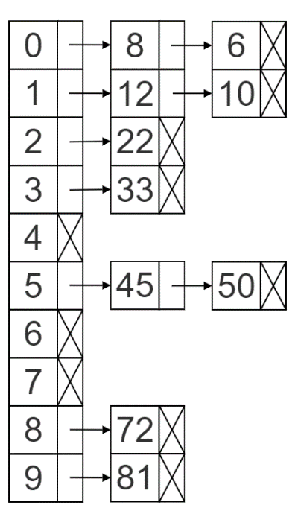
A: divider = ceil(82 / 10) = ceil(8.2) = 9, j = floor (arr[i] / 9), placing every number in its bucket:

Then sort every bucket using any sorting algorithm, for example selection sort, it will become sorted:
6, 8, 10, 12, 22, 33, 45, 50, 72, 81

Q7. You need to find the k-th key inside an unsorted list. The problem is simpler than sorting the full list. Give a simplification of Quick Sort algorithm that finds the k-th key with less cost. Your presentation of this algorithm should:
- outline the solution idea
- give a pseudocode level statement of the algorithm (using the critical variables)
- analyze the average cost.
A: We select a pivot then we put it in its place, now every element on the left of the pivot will be less than it, and every element on the right of it will be bigger than it, so now to find the k-th key we should check if the pivot is before the k-th place or after, if before then we pick the right sub array, & if after then we pick the left sub array. Repeat until the pivot is placed on the k-th place. (Search about QuickSelect)
left = 0, right = list.size-1, pivotIndex = selectPivotFrom(left, right)
while pivotIndex != k:
pivotIndex = putPivotInPlaceUsingQuicksort(left, right, pivotIndex)
if pivotIndex > k:
right = pivotIndex - 1
pivotIndex = selectPivotFrom(left, right)
else if pivotIndex < k:
left = pivotIndex + 1
pivotIndex = selectPivotFrom(left, right)
else:
Print("The k-th element is:", list[pivotIndex])
The average cost: Θ(n)
1. The graph is considered to be dense if:
a) |E| ≈ |V| b) |E| ≈ |V|² c) |E| ≈ (|V|-1) d) |E| ≈ |V| * 2
A: b

2. If G is an undirected graph with m edges, then:
a) Σ deg(v) = 2m = |E| b) Σ deg(v) = 2m = 2-|E|
c) Σ deg(v) = 2m = 2|E| d) Σ deg(v) = 2m = |E|/2
A: c

3. If the graph is complete directed graph with V nodes (vertices), then it has:
a) V*(V-1)/2 edges b) V*(V-1) edges
c) E*(V-1)/2 edges d) None of them
A: b

4. Having this array is being sorted by Quick Sort: [4,3,2,5,8,7,9] which of the following could be the pivot, why?
a) 3 b) 5 c) 7 d) 9 e) 5 & 9 f) None of them
A: e, because they’re in the right place, elements on left are less than it & elements on right are higher than it.

5. Spanning tree is:
a) A set of |V|-2 edges that connect all vertices of a graph.
b) A set of |V|²-1 edges that connect all vertices of a graph.
c) A set of |E|-1 edges that connect all vertices of a graph.
d) A set of |V|-1 edges that connect all vertices of a graph.
A: d

6. A spanning subgraph of G is a subgraph that contains all the _____ of G.
a) Edges b) Edges & vertices c) Vertices d) None of them
A: c

7. Having the following array A=[5,10,15,20,30], applying build heap on it then the result is:
a) A=[20,30,15,5,10] b) A=[10,30,15,5,20]
c) A=[30,20,15,5,10] d) None of them
A: c

8. Left & right rotate of binary search tree preserve the order in case of:
a) in-order traversal & pre-order traversal.
b) in-order traversal and post-order traversal.
c) in-order, pre-order and post-order traversal.
d) in-order traversal only.
A: d

1. Heap sort is in-place sorting algorithm. A: T
2. In Heap, for every node i other than the root A[parent(i)] <= A[i]. A: F, it should be >=
3. In Heap, the left child of node i is A[2i+1]. A: F, it should be A[2*i]
4. BST is balanced if height of left & right of sub-tree of each node differ by at most one. A: T
5. An undirected graph is connected if you can get from any node to any by following a sequence of edges OR any two nodes are connected by path. A: T

